Power BI Lab 2 Report
Tamar Tutisani

Introduction
This lab continues from Lab 1, using the same AdventureWorks dataset and model. The goal was to build a complete, well-structured report in Power BI Desktop and publish it to Power BI Service. Below are the steps taken along with screenshots of the results.
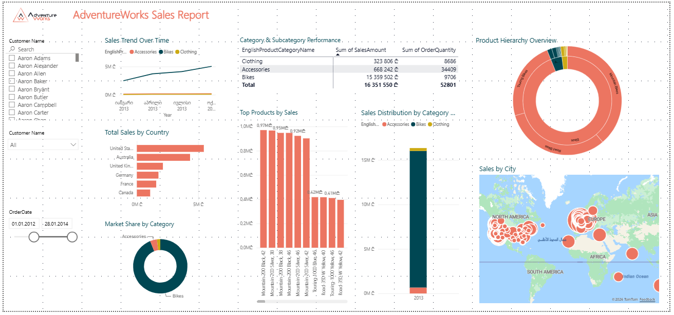

WORKING WITH POWER BI REPORT
To allow users to filter the report by customer name, I added two slicers both using the Full Name field from the DimCustomer table. The first slicer was left in its default List format, which displays all customer names as a scrollable checklist. This is useful when the user wants to see all available options at once. The second slicer was switched to Dropdown format by clicking the slicer's … menu and selecting Dropdown, which saves canvas space while still giving full filtering functionality.
Search was enabled on both slicers via the same … menu, since the customer list is very large and scrolling through it manually would be impractical. With Search, users can type a name and immediately narrow down the results, significantly improving the user experience.
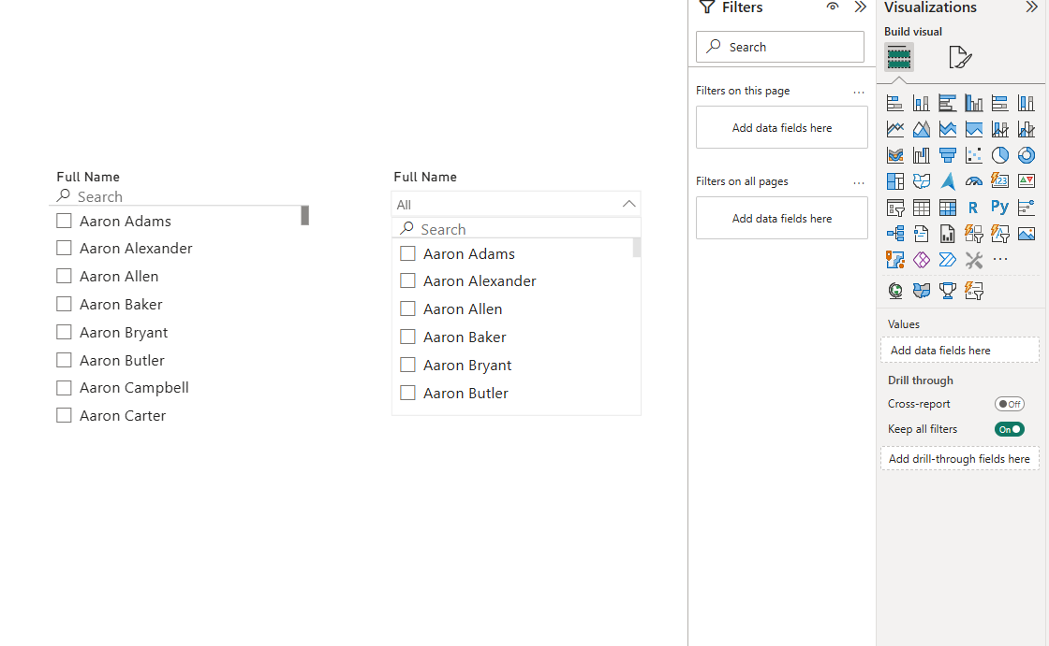
Screenshot 1. Two Different Types of Slicers with Search

I imported three custom visuals from the Power BI AppSource marketplace by clicking the … at the bottom of the Visualizations pane and selecting Get more visuals.
The three custom visuals added were Chiclet Slicer, Bullet Chart, Sunburst.
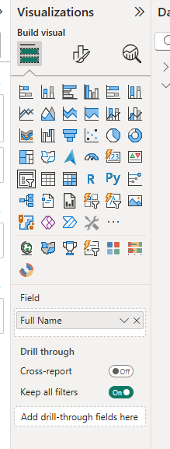
Screenshot 2. Added Chiclet Slicer, Bullet Chart and Sunburst from AppSource

RQ1
Following the page structure principle from the design essentials - "Where am I?", I added a clear header at the top of the report. The AdventureWorks logo was inserted using Insert -> Image and sourced from Google. A Text Box was added next to it with the report title "AdventureWorks Sales Report" formatted in a large, bold font using the report's color palette.
Both the logo and the text box were then grouped together so they behave as a single unit and stay aligned when the canvas is resized. This header immediately tells the user what report they are viewing and establishes the visual identity of the report.
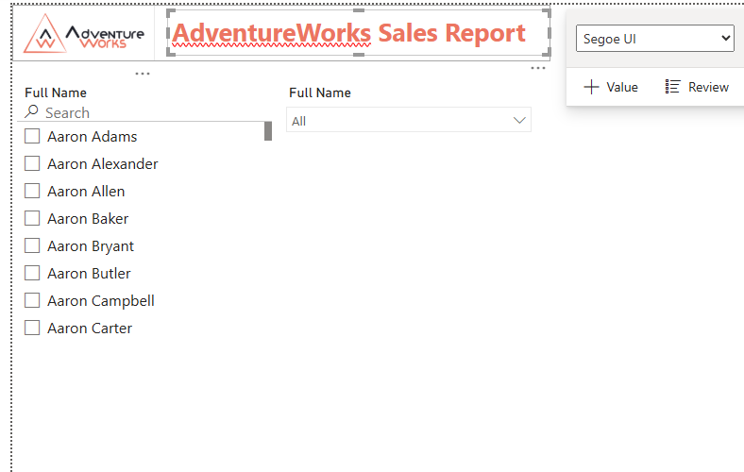
Screenshot 3. Added logo and title as header and grouped it together
Logo source: https://endorsal.io/reviews/adventureworks-wa

RQ2
A date slicer was added using the OrderDate field from the FactInternetSales table. It was configured in Between mode, which displays a slider with two date handles representing the start and end of the selected date range. The current range covers 01.01.2012 to 28.01.2014, matching the available data in the dataset.
This is the third slicer type in the report, completing the requirement for three different slicer formats. A date slicer is particularly useful here because sales analysis is inherently time-based, and giving users control over the date range allows them to focus on specific periods without modifying the report itself.
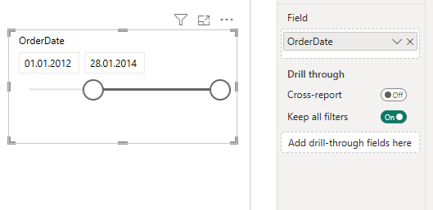
Screenshot 4. Date Slicer (OrderDate)

RQ3

Line Chart
A Line Chart was added to show sales trends over time. The X-axis uses the OrderDate field with the full date hierarchy (Year, Quarter, Month, Day), and the Y-axis shows Sum of SalesAmount. The Legend is set to EnglishProductCategoryName from DimProductCategory, resulting in three separate lines for Accessories, Bikes, and Clothing.
The chart was drilled down to the Month level within 2013 using the drill-down arrows on the visual, which gives a more granular view of how sales moved throughout the year. Per the design essentials, the number of lines is kept to 3, all lines are solid, and colors are clearly distinguishable. A grid is visible to help users identify exact values.
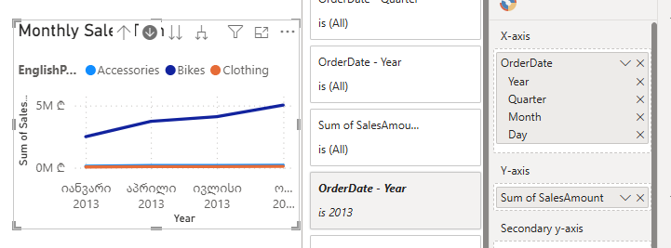
Screenshot 5. Line Chart (Sales trend over time) drilled to 2013

Clustered Bar Chart
A Horizontal Clustered Bar Chart was used to compare total sales across different countries. The Y-axis contains SalesTerritoryCountry from DimSalesTerritory, and the X-axis shows Sum of SalesAmount. The chart is sorted in descending order by SalesAmount so the highest-performing countries appear at the top.
A horizontal bar chart was chosen here specifically because, as noted in the design essentials, horizontal bars are best for comparison and ranking, which is exactly the purpose of this visual. The United States leads sales by a significant margin, followed by Australia and the United Kingdom.
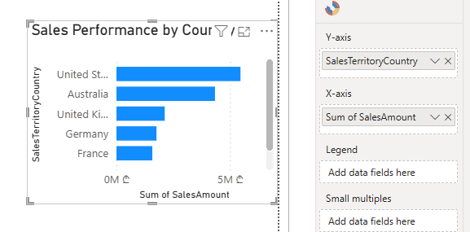Screenshot 6. Clustered Bar Chart (Sales by Country) sorted by SalesAmount in descending order

Stacked Column Chart
A Stacked Column Chart was added to show how total sales are distributed across product categories for each year. The X-axis uses the Order Year calculated column created in Lab 1, the Y-axis shows Sum of SalesAmount, and the Legend is set to EnglishProductCategoryName.
This chart type was chosen because it is best for showing part-to-whole relationships while also allowing comparison of total sales across years. The axis starts at zero as recommended by the design essentials, and each category segment uses a clearly distinguishable color. The dominance of the Bikes category is immediately visible across all years.
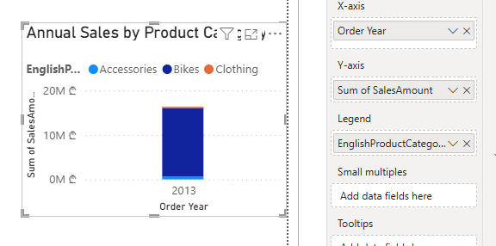
Screenshot 7. Stacked Column Chart (Sales by Category per Year)

Matrix
A Matrix visual was added to provide precise numerical detail alongside the charts. The Rows field contains both EnglishProductCategoryName and EnglishProductSubcategoryName from their respective dimension tables, creating an expandable hierarchy. The Values fields are Sum of SalesAmount and Sum of OrderQuantity.
This visual was chosen because a data table is best when exact values are important and when users need to compare figures at a detailed level. The matrix allows users to collapse or expand categories to view subcategory-level data, making it both informative and space-efficient.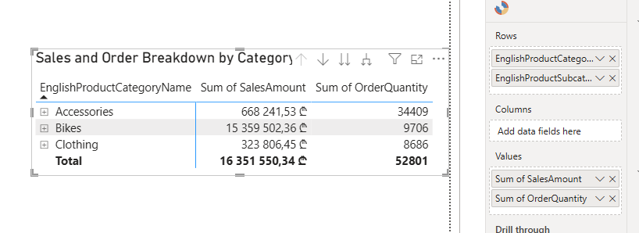
Screenshot 8. Matrix (Sales and Order Breakdown by Category)

Donut Chart
A Donut Chart was used to show each product category's share of total sales. The Legend is set to EnglishProductCategoryName and the Values field uses Sum of SalesAmount. Data labels are shown directly on the chart segments to avoid relying solely on the legend.
The chart has only 3 slices and the colors are clearly distinguishable. The Bikes category makes up approximately 93.93% of total sales, which is immediately obvious from the visual without any additional analysis.
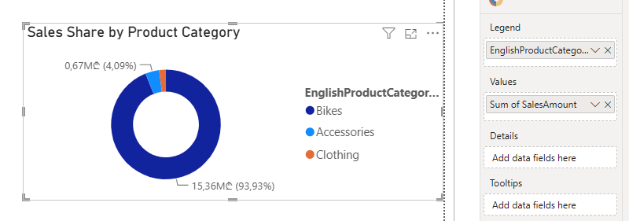
Screenshot 9. Donut Chart (Sales share by Category)

Clustered Column Chart
A Clustered Column Chart was added to display the top-performing products ranked by total sales amount. The X-axis shows product names sorted in descending order by SalesAmount, and the Y-axis displays the total sales amount for each product. Data labels are enabled on each column to show exact values.
This visual was chosen because it provides a clear ranking of product performance, making it immediately obvious which products generate the most revenue. Unlike the previous Bullet Chart configuration (which showed discount amounts that were consistently zero and provided no business insight), this chart highlights actual sales performance and complements the Sunburst visual by offering both a hierarchical view (Sunburst) and a flat, ranked view (Column Chart) of product data. The column chart format is ideal for comparing individual products and identifying top performers at a glance.
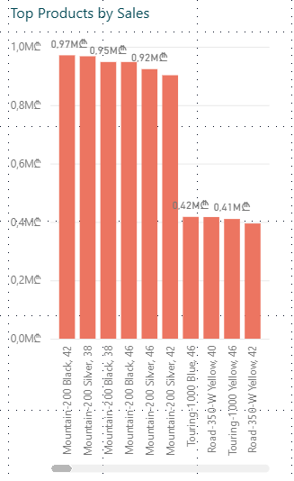
Screenshot 10. Clustered Column Chart - Top Products by Sales

Sunburst - Custom Visual
The Sunburst custom visual was configured with EnglishProductCategoryName and EnglishProductSubcategoryName in the Groups field, and Sum of SalesAmount as the Value. The outer ring represents subcategories and the inner ring represents the parent categories, allowing users to drill down into the product hierarchy within a single visual.
This visual was chosen because the AdventureWorks product structure is inherently hierarchical, and a Sunburst makes that hierarchy immediately visible. It complements the Matrix visual by providing the same hierarchical breakdown in a more visually engaging format, which is appropriate for an overview page of a report.
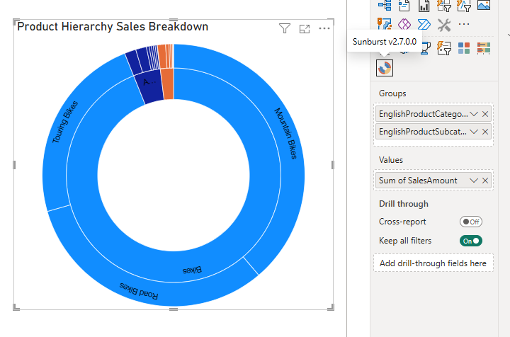
Screenshot 11. Sunburst (Product Hierarchy Sales Breakdown)

RQ4
To demonstrate the Edit Interactions feature, I selected the OrderDate date slicer and clicked Format -> Edit Interactions in the top ribbon. This caused interaction control icons to appear above every other visual on the canvas. I then clicked the None (X) icon above the Donut Chart, which disables the slicer's filtering effect on that specific visual.
The reason for this configuration is intentional: the Donut Chart is meant to always display the overall sales share by category across the full dataset, regardless of what date range is selected. This gives users a stable reference point for category proportions while they explore time-based trends using the other visuals on the page.

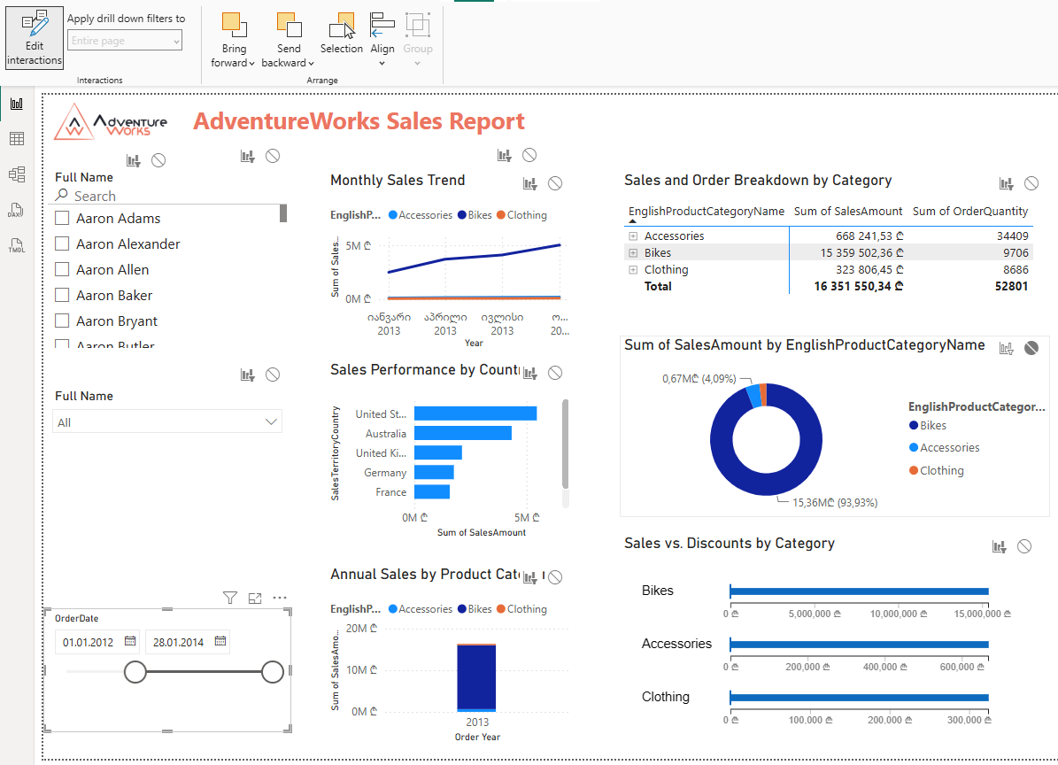
Screenshot 12. Disabling the Date Slicer for the Donut Chart

RQ5
A consistent color palette was applied across all visuals to create a cohesive and professional appearance. The colors were chosen to complement the AdventureWorks brand, using the red-orange tones from the logo as the primary accent color, with dark navy and teal as supporting colors.
The theme was customized via View -> Themes -> Customize current theme, where the primary colors were set and applied globally. Charts, text elements, and background accents all follow this palette. Per the design essentials, colors are used strategically, not decoratively, to differentiate data series, highlight key metrics, and maintain visual consistency across the entire report.
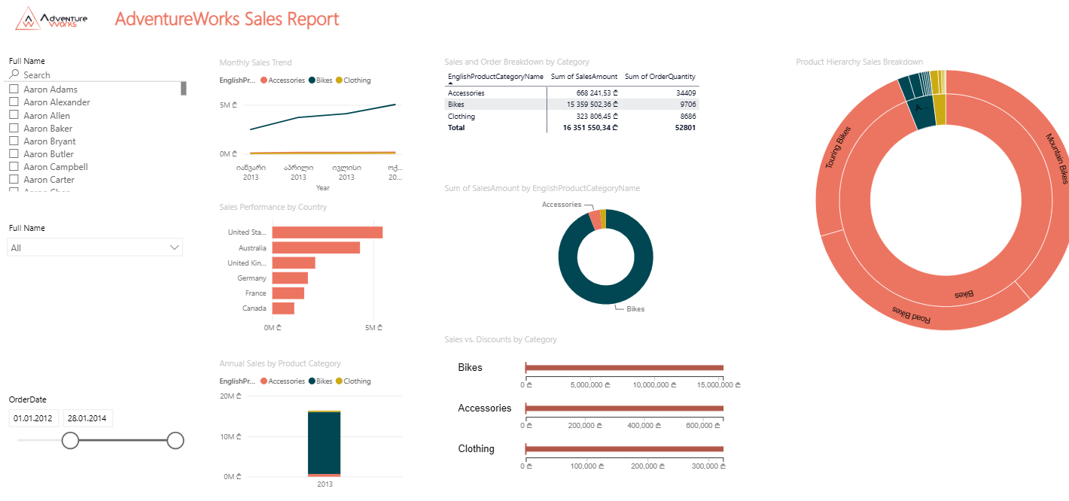
Screenshot 13. Color Grading

RQ6
A Map visual was added to the report to display sales data geographically. The Location field was set to City from the DimGeography table, which places a dot on the map for each city where sales were recorded. The map is zoomed in on Europe in this screenshot, where a high concentration of customer locations is visible across the UK, France, Germany and surrounding countries.
The map provides users with an immediate geographic sense of where sales are concentrated, which no chart or table can communicate as effectively. The geographic data is now fully integrated into the report's filter context through the DimCustomer ↔ DimGeography relationship, ensuring the map responds to all relevant filters (country, date range, product category, etc.) without displaying extraneous data. The map is kept clean with only city-level dots shown, avoiding visual clutter.
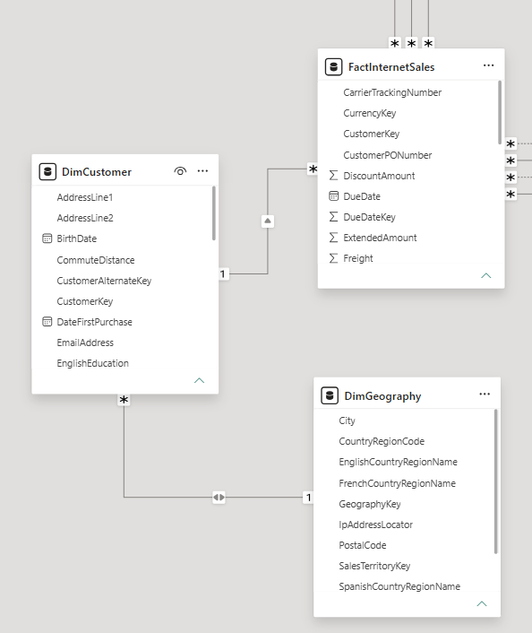
Screenshot 14. Re-established DimGeography relationship
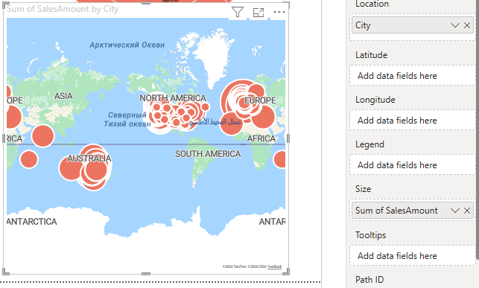
Screenshot 15. Map visual zoomed in on Europe

RQ7
The Mobile Layout was configured by navigating to View -> Mobile Layout in Power BI Desktop. This opens a phone-shaped canvas where visuals can be dragged and rearranged independently of the desktop layout.
The visuals were arranged in a logical top-to-bottom order suitable for a narrow screen: the header and slicers appear first for context and filtering, followed by the key charts (line chart, bar chart, stacked column), then the detailed visuals (matrix, donut, bullet chart, sunburst), and finally the map at the bottom. Each visual was resized to fit the phone width without horizontal scrolling.
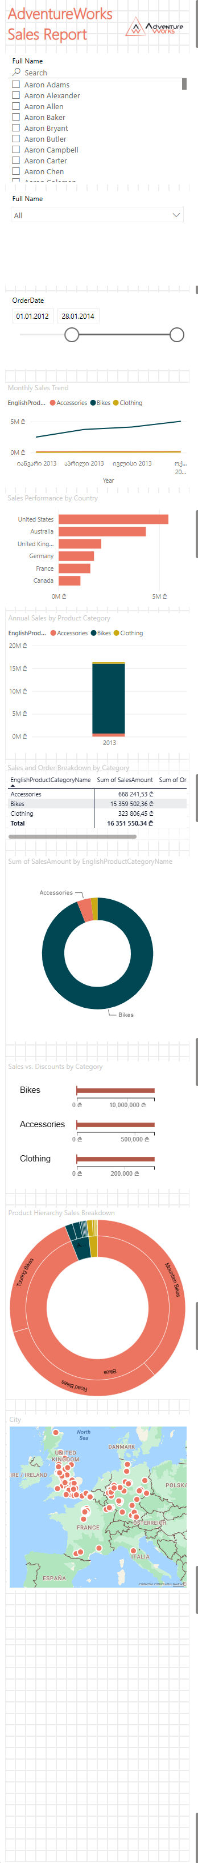


RQ8
After completing the report, it was published to Power BI Service by clicking Home -> Publish in Power BI Desktop and selecting My Workspace as the destination. The publishing process completed successfully as confirmed by the success dialog.
The report was then opened in the browser at app.powerbi.com to verify that all visuals, slicers, and interactions transferred correctly to the service. The published report is accessible at:
https://app.powerbi.com/groups/me/reports/99fcf5de-c7cb-4f7d-8e87-5a551e407dd8/7a64566ba6b819620260?experience=power-bi
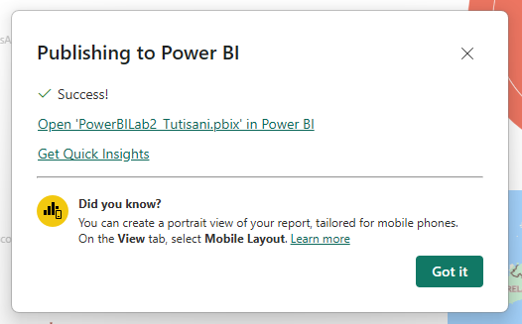
Screenshot 16. Publishing to My Workspace
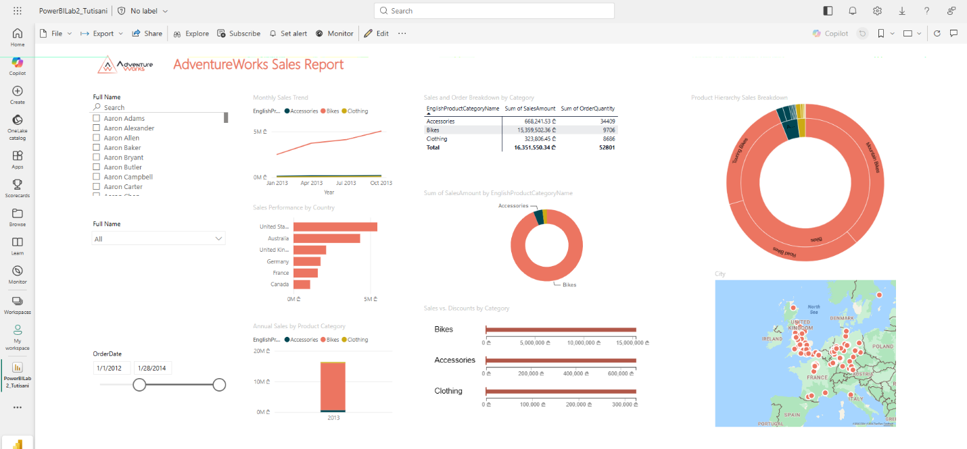
Screenshot 17. Published

RQ9
To configure automated data refresh, I installed a Personal Gateway to allow Power BI Service to connect to the local SQL Server. Once the gateway was set up, I navigated to the PowerBILab2_Tutisani semantic model Settings in My Workspace and expanded the Refresh section, where the schedule was configured as follows:
- Frequency: Daily
- Time: 7:00 AM UTC
- Notifications: enabled for the semantic model owner in case of refresh failure
This ensures the report data is updated once every day automatically, keeping the visualizations current without requiring manual intervention.
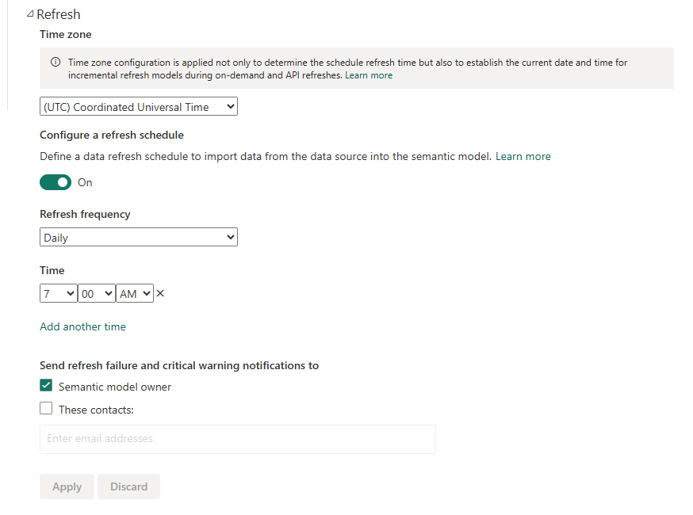
Screenshot 18. Scheduled refresh

RQ11
The following link opens the report pre-filtered to show data for the Australia only:
https://app.powerbi.com/groups/me/reports/99fcf5de-c7cb-4f7d-8e87-5a551e407dd8/7a64566ba6b819620260?experience=power-bi
This feature is useful for sharing a focused view of the report with specific stakeholders, for example, sending Australia sales team a link that opens directly filtered to their territory, without them needing to interact with the slicers manually.

Conclusion
This lab covered the full cycle of building and publishing a Power BI report, from designing visuals and applying a consistent color theme, to configuring slicers, interactions, mobile layout, and finally publishing to Power BI Service with a scheduled refresh. The finished report is structured clearly, uses a variety of visual types appropriate to the data, and is accessible to end users both on desktop and mobile.
The Power BI file is uploaded as PowerBILab2_Tutisani.pbix and the published report link was shared with the mentor via tamar_tutisani@epam.com.

